

**unicat online learning**

**Final Release Document**

– Hoa lac, Mar 2023 –

**Table of Contents**

I. Deliverable Package 3

II. Installation Guides 3

1. Installing JDK 18.0.2 3

2. Installing Apache Tomcat 10.0.18 4

3. Installing Apache NetBeans IDE 13. 10

4. Integrating Apache NetBeans IDE 13 with Apache Tomcat. 11

III. User Manual 18

1. Overview 18

2. Workflow 18

# I. Deliverable Package

| **No.** | **File** | **Notes** |
| --- | --- | --- |
| 1 | SWP391-LearningOnlineProject_DB_final.sql | Database, including both table structures and table data |
| 2 | SWP391-LearningOnlineProject_SRS.docx | Final SRS (Requirement) Document |
| 3 | SWP391-LearningOnlineProject_SDS.docx | Final SDS (Design) Document |
| 4 | SWP391-LearningOnline_Project-Tracking.xlsx | Final status for the application functions, which include:  - Function name, feature, roles, function description (changes compared to the original requirements are highlighted)  - In Charge, Planned iteration & Actual iteration  - Final status & note on the update you made  - The links to the SRS & SDS are tracked |
| 5 | SWP391-LearningOnline_Project_Issues Report.xlsx | Final issues tracking list of the whole project |

Other related deliverables:

* Tagged source codes: <https://github.com/acradibotC/unicat_online-learning>
* Link demo: <https://unicat.azurewebsites.net>

# II. Installation Guides

## 1. Installing JDK 18.0.2

Page:<https://www.oracle.com/java/technologies/downloads/>

Scroll down to find the version you need.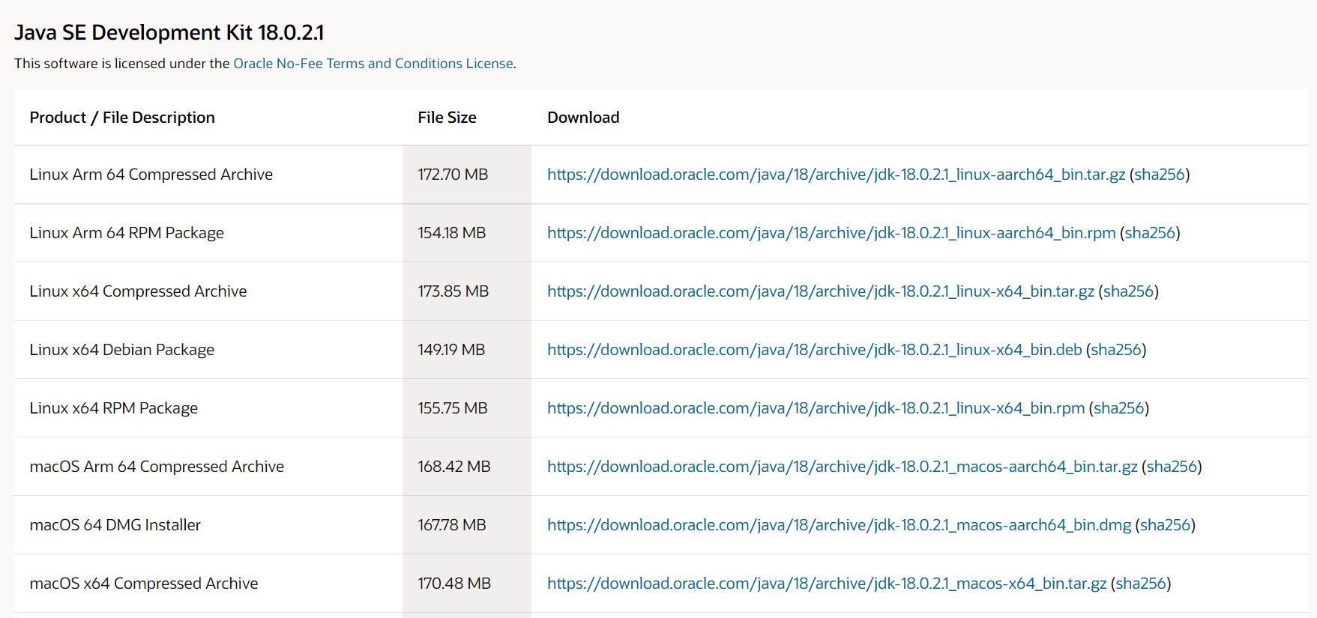

After installing, let check the installation folder:

Normally it will be located at: C:\Program Files\Java. It contains 2 folders JDK and JRE.



If you see these folders, it is ok for now.

For more you can read on link:

<https://www.oracle.com/java/technologies/javase-jdk8-doc-downloads.html>

## 2. Installing Apache Tomcat [10.0.18](https://tomcat.apache.org/download-10.cgi#10.0.18)

Download page:<https://tomcat.apache.org/download-10.cgi>

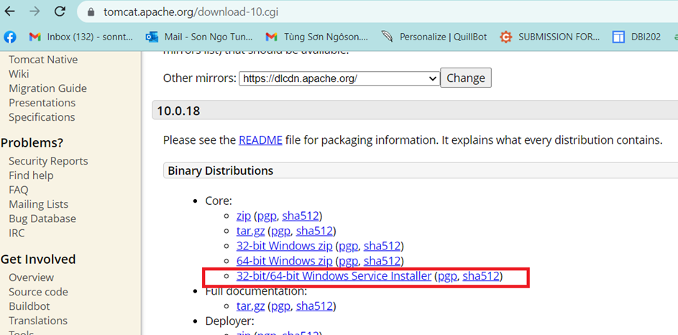

Open the installer file then click “Next” button, until you see the below screen

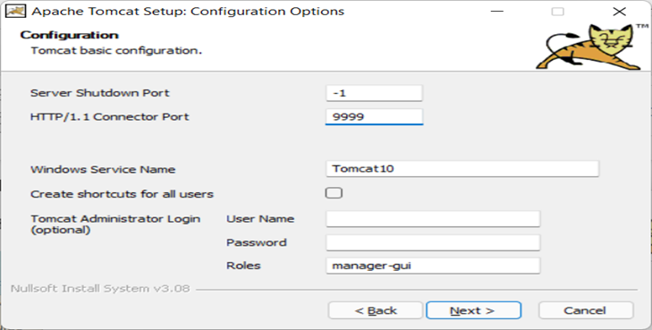

By default, the HTTP port is set as 8080, but I prefer to change it to 9999. You can keep it as 8080 or change it as you desire. Same for Window Service Name.

You can also set username and password at this step, but it is an optional and you can do it later.

Click “Next”, then the installer will ask you for JRE folder. Basically, the installer can automatically detect JRE folder, but in the case it cannot, you can add it manually.

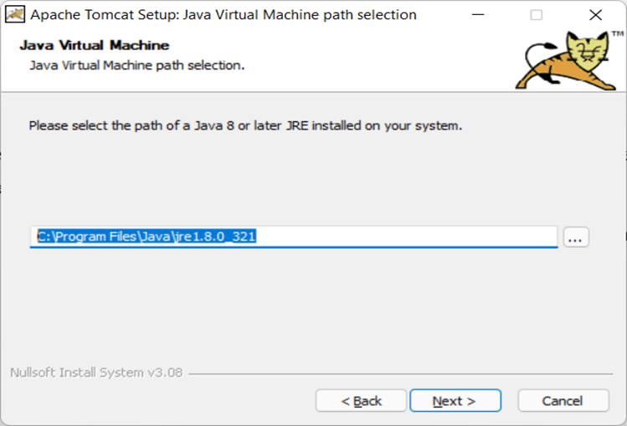

Click “Next” …. Again then “Finish”.

Normally, you are going to see the below window app displayed:

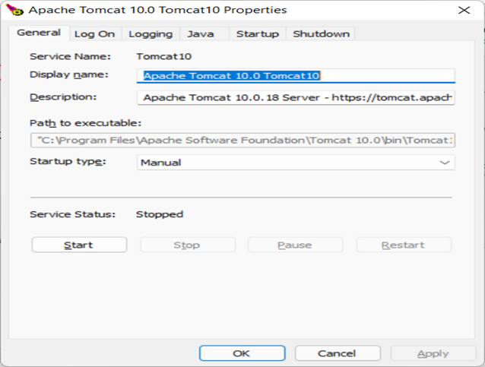

It is ok, this application used to control your TOMCAT webserver, but if you do not see it, do not worry. I recommend you follow below instructions:

1. TOMCAT now is installed as a Window Service (It is a software, but it does not have a graphic user interface).

2. To work with Window Service, press window+R, fill service.msc

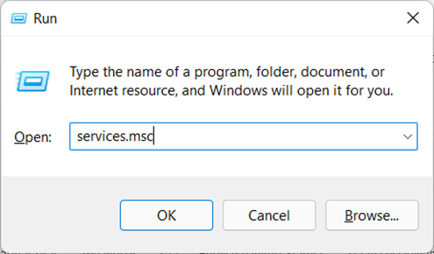

3. Find the TOMCAT service in the list:

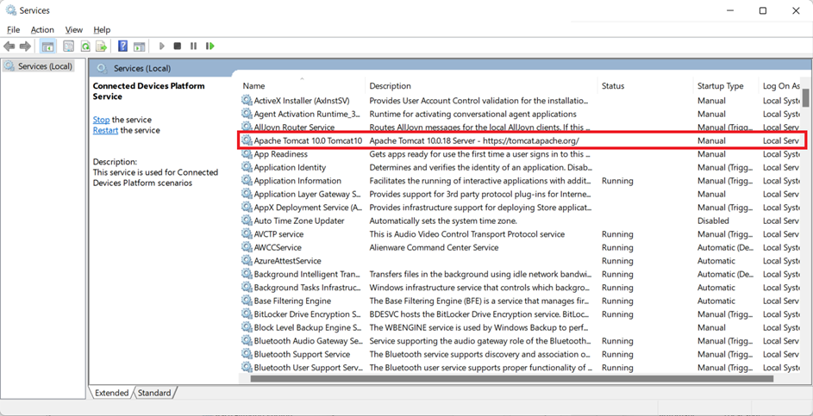

Right click -> properties ->

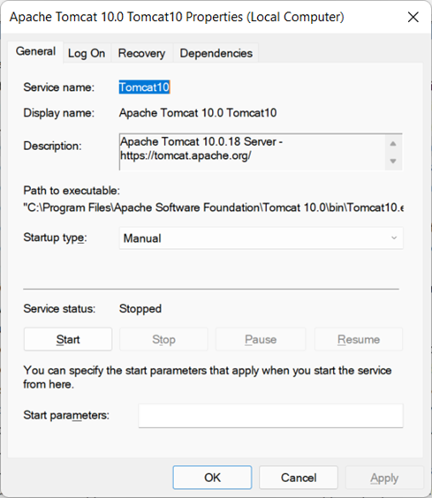

Now you can start/stop the TOMCAT service. Just make sure it is running before use.

You can grant permission for TOMCAT to run with a Local System account on the same dialog.

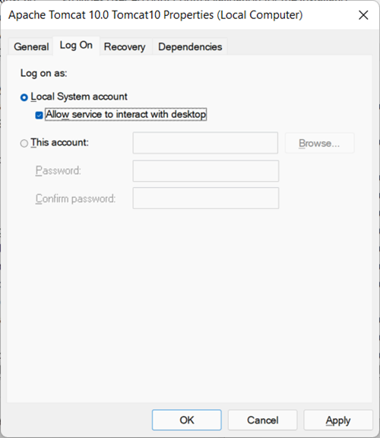

## 3. Installing Apache NetBeans IDE 13.

Download: <https://netbeans.apache.org/download/nb13/nb13.html>

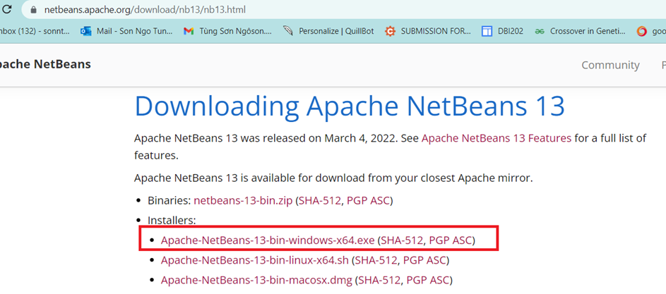

During your installation, remember to select JDK 1.8 (just in case, you have more than one version of Java).

After installation, run netbeans 13, File > New Project > Java with Ant > Select Web Application (It is disabled by default, just select it, netbeans will automatically enable the project template).

## 4. Integrating Apache NetBeans IDE 13 with Apache Tomcat.

+ First, open the Apache Tomcat folder:

By default, it is located at: C:\Program Files\Apache Software Foundation\Tomcat 10.0

The system may ask you to grant permission, just click the “Yes” button. This step aims to allow your account to access the Apache Tomcat folder for further tasks.

**+** Open netbeans, on the menu bar, Window > Service (ctrl + 5) > select Service panel as following:

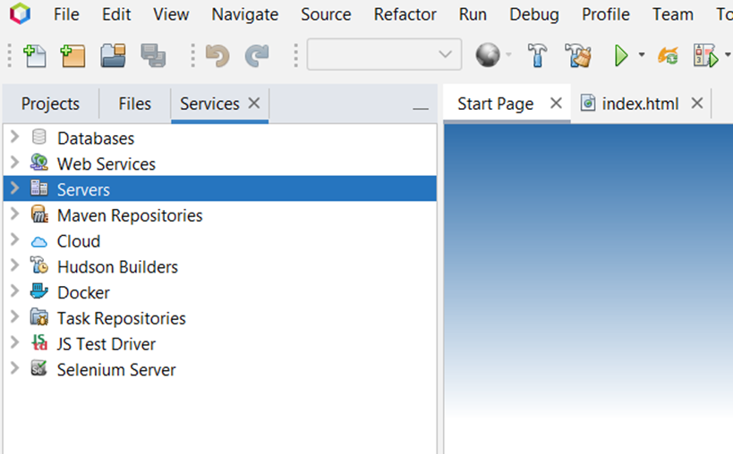

Server > Right click > Add Server > Apache Tomcat and TomEE >

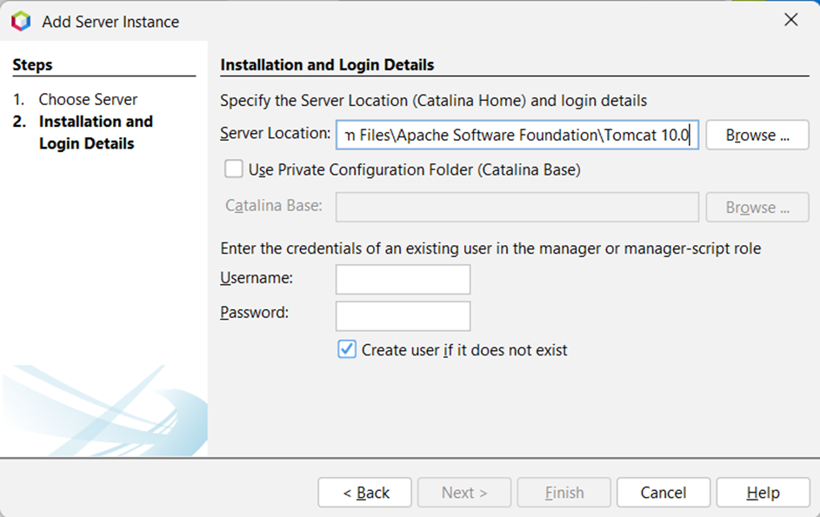

Here you can create your username and password, then finish. Now you can work with Java Web project in netbeans 13.

If you get an error related to “CATALINA_base is Invalid”, check the first step.

Errors related to Tomcat will be logged to “C:\Program Files\Apache Software Foundation\Tomcat 10.0\logs”, check the catalina**** file for the detail logs.

**5. Create Java Web project, Servlet and Debug.**

To create a new java web project: File > New Project > Java with Ant> Java Web > Web Application (See the below figure)

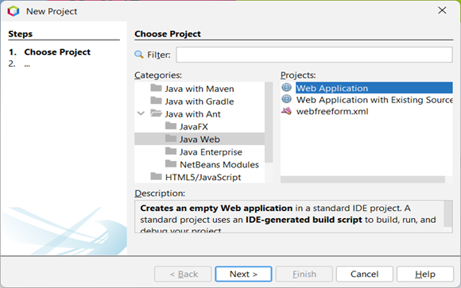

/// LET DO IT, IN THE SESSION OF SERVLET

Once you create new Servlet via Netbeans template file. By default, netbeans using javax, which is not included in the Jakarta EE platform equipped with Tomcat 10. Just need to replace all javax by Jakarta package, then everything will be compiled.

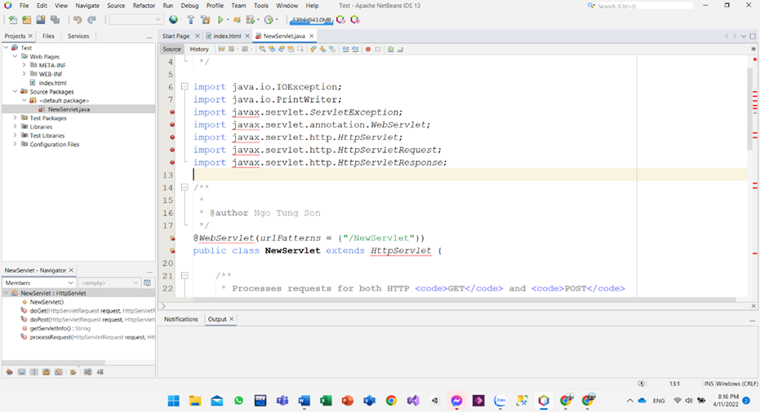

Refer to https://tomcat.apache.org/ for more detail

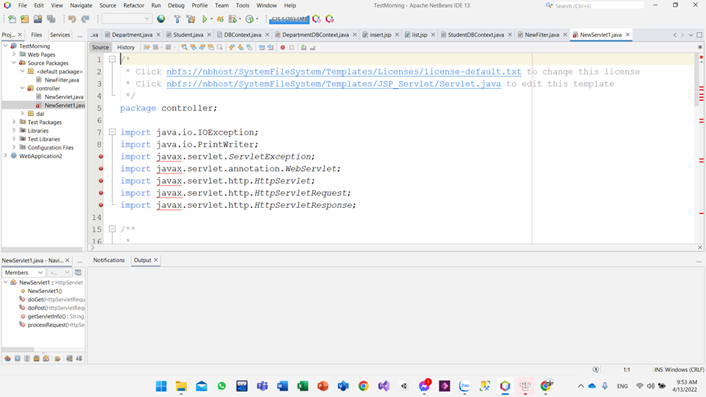

you can also edit the template file for further tasks.

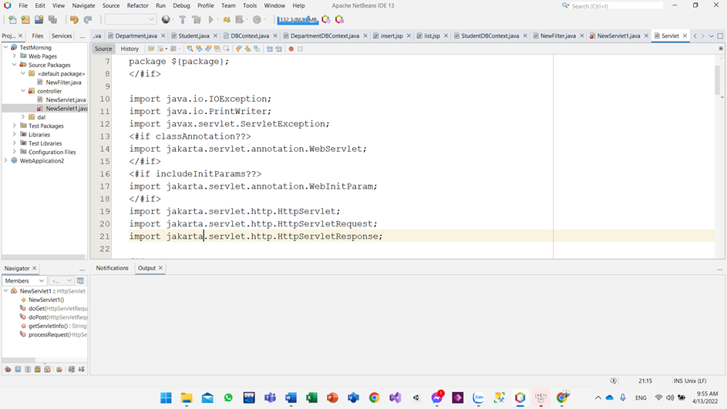

// For one who cannot start debugging mode with apache tomcat 10. Open the task manager window then kill the process of Java SE.

Check the video: https://youtu.be/9Zcy7yWNAm4

OR

Open window PowerShell, type command:

get-process

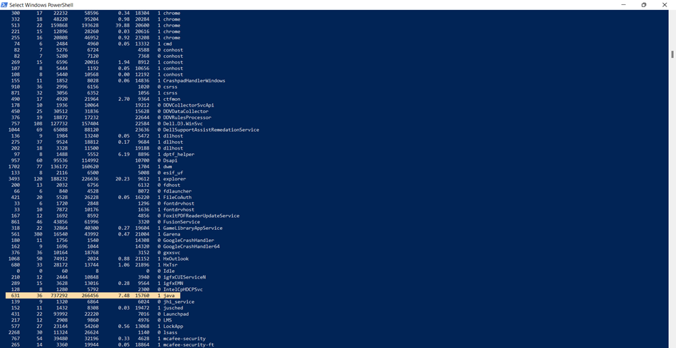

Find java-se process id, then type command:

taskkill /pid 15760 /F

Now you can try debugging again with NetBeans and tomcat.

**6. Working with JSTL.**

Latest version of JSTL built on J2EE was 1.2x. Since the Tomcat 10 is using the Jakartified version (with jakarta.* package instead of javax.* package), use JSTL 2.0 to solve this dependency:

Download: Jakarta Standard Tag Library API

Link: https://search.maven.org/artifact/jakarta.servlet.jsp.jstl/jakarta.servlet.jsp.jstl-api/2.0.0/jar

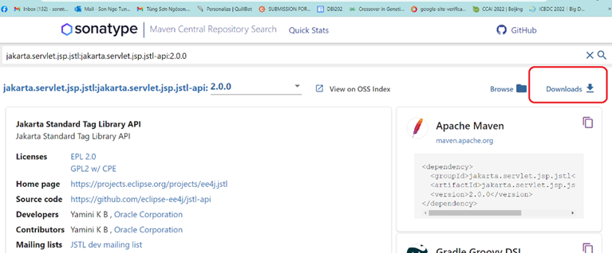

Download: Jakarta Standard Tag Library Implementation

Link: https://search.maven.org/artifact/org.glassfish.web/jakarta.servlet.jsp.jstl/2.0.0/jar

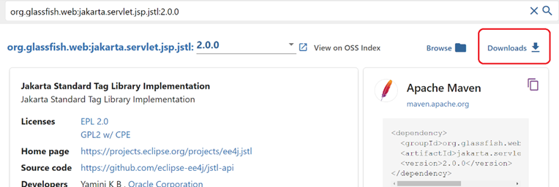

Check the document here:

https://jakarta.ee/specifications/tags/2.0/jakarta-tags-spec-2.0.html

# III. User Manual

## 1. Overview

* An online learning website is a platform that allows users to learn a course online. This website offers a wide range of courses related to information technology. The platform offers a user-friendly interface that allows users to browse, search, and learn courses with ease. The website also offers basic courses in programming languages, making it easily accessible to the software engineering industry, thus making it a convenient and reliable online learning destination.

## 2. Workflow

**Course Status Lifecycle**

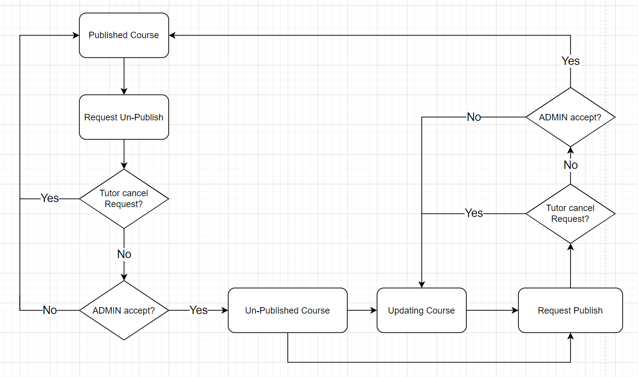

* This workflow is the course manager process. Admin needs to login admin’s account before can redirect to the course manager. The course manager process involves flinging out published courses, requesting unpublish courses, updating courses, and requesting publishing courses. Once the course is complete, the admin can publish or unpublish one course.
* To publish or unpublish one course on the learning website, follow these steps:

+) Open the website on your desktop.

+) Click on the “ Log in ” button on the header of home page.

+) After log in by admin’s account , click on the “ Admin Manger ” on the header of home page.

+) Click on the “ Publish Course ” on the navbar and click on the “ Request Un-Publish ” in course list.

+) If tutor cancel request, the page will redirect to Publish Course. Otherwise, if tutor don’t cancel, the request will be transferred to the admin so that the admin can accept or cancel the teacher's request.

+) If the admin accepts the request, the teacher can go to the "Un-Publish Course" section to be able to update the course or request Course. On the contrary, if the admin rejects the request from the teacher, the course will be transferred to "Course Publish".

+) After the teacher sends the request "Publish request" to the admin. If the admin refuses, that lesson will not be publish and if the admin accepts, the lesson will be pushed back "Published Course".